Git is the command line interface installed in your local machine

GitHub is like a repository in the cloud.

**Version control System**

* Centralized VCS
* Distributed VCS

**Creating a Git project:**

* Create a folder.
* Create a file inside the folder
* Convert the folder into git project ---> **git init**

Change the user ID & email ----> **git config –global --edit**

* Check status -----------> **git status**
* add file to repo --------> **git add “FILE_NAME”**
* Commit your changes ----------> **git commit -m “COMMENTS”**
* To check the destination repository -----------> **Git remote –v**
* To add destination repository on github ---------> create a git repo on your github account and add to the repo

**git remote add origin** [**https://github.com/yaswanthvarma/first.git**](https://github.com/yaswanthvarma/first.git)

* To change the URL

**git remote set-url origin** **git@github.com:yaswanthvarma/second.git**

* To push changes to the github repository ----> **git push origin master**

**git clone** means you are making a copy of the repository in your system.

**git fork** means you are copying the repository to your Github account.

**git pull** means you are fetching the last modified repository.

**git push** means you are returning the repository after modifying it.

In layman's term: **git clone** is downloading and **git pull** is refreshing.

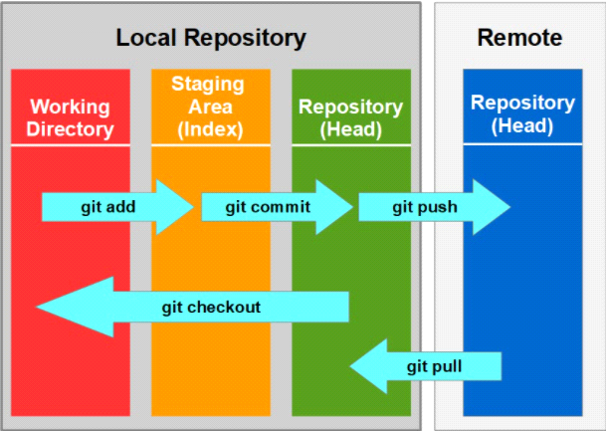

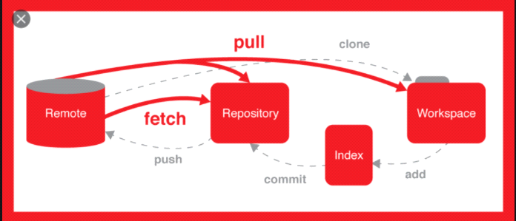

**GIT operations and commands:**

**GIT Configurations**

Initial config of username, email and code highlighting (optional) is to be performed.

$GIT config — global user.name”firstname lastname”

$GIT config — global user.email” abc123@abc.com”

$GIT config — global color.ui true (enables code highlights)

$GIT config –list

**Initialize**

**You have to initialize by using ‘init’ :** $GIT init

**To know the status run the ‘status’ command :** $GIT status

**Create/Add files:**

**To add a file:** $GIT add<filename>

**To add multiple files:** $GIT add<filename> <2nd filename> <3rd filename>

**To add all updated files:** $GIT add –all ( use -A instead of -all too )

**To remove files:** $GIT rm -r <filename>

**Commit changes:**

**To pass a message, use ‘commit’ and ‘-m’ :** $GIT commit -m “body_of_message”

**To amend the last commit or the last message :** $GIT commit –amend -m “new_message”

**Push and Pull**

A remote repository typically represents a remote server or a GIT server.

Create a remote repository via GIThub “[https://GIThub.com/YourUsername/appname.GIT](https://github.com/YourUsername/appname.GIT)”

**To add a link :** $GIT remote add origin<link>

**Pushing files :** $GIT push -u origin master

**To clone file :** $GIT clone <clone>

##################################################################################

<https://www.youtube.com/watch?v=RGOj5yH7evk>

**Setting ssh keys for github authentication:**

<https://docs.github.com/en/github/authenticating-to-github/generating-a-new-ssh-key-and-adding-it-to-the-ssh-agent>

ssh-keygen -t ed25519 -C “reachyaswanth@gmail.com”

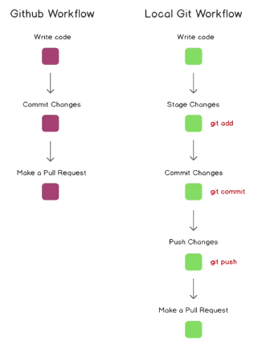

Local git workflow:

$ git init

$ git add –m “description” -m “description”

$ git commit

$ git remote add origin

$ git push

$ git clone “repository address”

$ git remote –v

$ git push origin master

Origin

**origin**" is a shorthand name for the remote repository that a project was originally cloned from. More precisely, it is used instead of that original repository's URL

Master

**Git Branching**

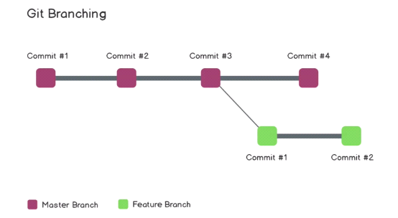

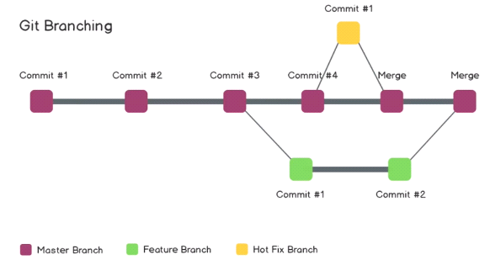

git branch --list

git branch <BRANCH_NAME> // to create a new branch

git checkout <BRANCH_NAME> // switch to another branch

Git checkout -b “BRANCH_NAME”    //create a new branch & switch to it

Git branch -d “BRANCH_NAME”       //delete a branch

Head points to the last commit on the repo that you are currently on,

**$ Git checkout**

**$ Git merge**

**#################################################################################**

**CS visualized: useful git commands**

<https://dev.to/lydiahallie/cs-visualized-useful-git-commands-37p1>

<http://practicalseries.com/1002-vcs/02-02-concept.html>

<https://pragatisaikia.hashnode.dev/a-beginner-guide-to-git-and-github?source=personalized-newsletter&source-id=2023-02-16#heading-git-and-github-in-laymans-terms>

<https://github.com/Mo7ammed-AI/Try-Git-and-Github>